CSC 591, Homework Generalized Linear Models

Student Id: 200261202

Mkhan8@ncsu.edu

**Solution 1:**

Let $X_{h}$ be the predictor with the highest estimate (in terms of its absolute value) for its regression coefficient.

Regression coefficient $X_{h}$ will highest coefficient is dummy_EverythingElse with a coefficient value of -2.127e+00. So, we can say that $X_{h}→dummy_EverythingElse$.

Using $X_{h}$ as a single predictor for $fit.single$, the value of response variable



$$z= 0.12281+(-2.32004* dummy_EverythingElse)$$

$Prob\left(Y=Yes \right| X_{h}=x)=\frac{1}{(1+e^{-(0.12281+\left(-2.32004* dummy_EverythingElse\right))} )}$

$odds= \left(\frac{p}{1-p}\right)=e^{z}= e^{0.12281+\left(-2.32004* dummy_EverythingElse\right)}$

$logit\left(p\right)= log\left(\frac{p}{1-p}\right)= β0 + β1*x1 + … + βk*xk=z$

$$logit\left(p\right)=0.12281+(-2.32004* dummy_EverythingElse)$$

**Solution 2:**

The top four coefficients of fit.all model are:

* dummy_EverythingElse (2.126912)
* dummy_GBP (1.739977)
* dummy_Health/Beauty (1.608681)
* dummy_Coins/Stamps (1.359195)

$$z= -0.6115-2.126912*dummy_EverythingElse +1.739977* dummy_GBP -1.608681*dummy_Health/Beauty -1.359195 *dummy_Coins/Stamps$$

$logit\left(p\right)=z=-0.6115-2.126912*dummy_EverythingElse +1.739977* dummy_GBP -1.608681*dummy_Health/Beauty -1.359195 *dummy_Coins/Stamps$

$odds= \left(\frac{p}{1-p}\right)=e^{z}=e^{-0.6115-2.126912*dummy_EverythingElse +1.739977* dummy_GBP -1.608681*dummy_Health/Beauty -1.359195 *dummy_Coins/Stamps}$

$Prob=\frac{1}{\left(1+e^{-z} \right)}= \frac{1}{(1+e^{-(-0.6115-2.126912*dummy_EverythingElse +1.739977* dummy_GBP -1.608681*dummy_Health/Beauty -1.359195 *dummy_Coins/Stamps )} )}$

**Solution 3:**

The highest coefficient $X_{h}$ of the fit.all model is dummy_EverythingElse with a value of -2.126912. If we increase the value of $X_{h}$ by 1 keeping all the other co-efficient constant, the value of log odd will increase by $e^{coeffient of X_{h}}$.

We know the odds is given by $odds(X_{1},X_{2},…,X_{q})=e^{z}$ where $Z=β_{0}+ β_{1}X_{1}+….+β_{q}X_{q}$

If we increase the value of $X_{h}$ by 1 🡪 ,

Where $β_{h}is the coefficient of X_{h}$

$$\frac{odds(X_{1}+1,X_{2},…,X_{q})}{odds(X_{1},X_{2},…,X_{q})}=\frac{e^{z_{1}}}{e^{z}}=\frac{e^{β_{h}*z}}{e^{z}}=e^{β_{h}}$$

We know that $β_{h}=-2.126912$

$$\frac{odds(X_{1}+1,X_{2},…,X_{q})}{odds(X_{1},X_{2},…,X_{q})}=e^{-2.126912}=0.1192$$

In case of linear regression: $odds\left(X_{1},X_{2},…,X_{q}\right)=z= β_{0}+ β_{1}X_{1}+….+β_{q}X_{q}$

And $odds\left(X_{1}+1,X_{2},…,X_{q}\right)=Z_{1}=β_{h}z$

$\frac{odds(X_{1}+1,X_{2},…,X_{q})}{odds(X_{1},X_{2},…,X_{q})}= \frac{{(β}_{h}z)}{z}= β_{h}$

In this case, the value will decrease by the value of the coefficient i.e. 2.126912

**Solution 4:**

The output of summary statistics of fit.all model:

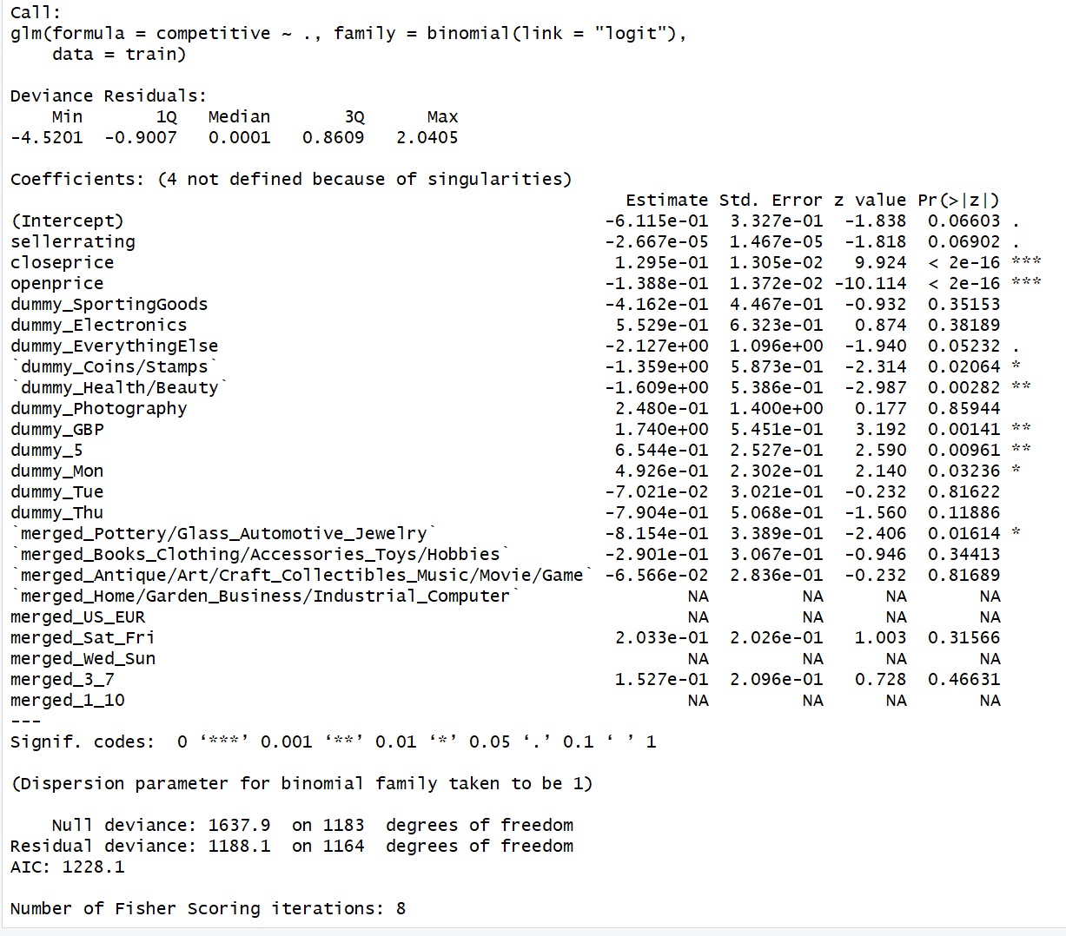

The significant coefficients from the summary statistics of fit.all model are:

* Openprice
* Closeprice
* dummy_Health/Beauty
* dummy_GBP
* dummy_5
* dummy_Mon
* merged_Pottery/Glass_Automotive_Jewelry
* dummy_Coins/Stamps

**Model Comparison:**

Accuracy:

Fit.all model: 80.5%

Fit.reduced: 80.2%

Chisquare test:

anova(fit.reduced, fit.all, test='Chisq') 🡪 0.04615

* at $α=0.01$ and 0.001: the value 0.046 is non-significant. The null hypothesis is accepted, and the alternate hypothesis is ignored. Therefore, we can say that the models are equivalent.
* at $α=0.$ 05: the value 0.046 is significant. The null hypothesis is ignored. Therefore, we can say that the models are not equivalent.

**Solution 5:**

We know that,

For a well-fitting model: Residual Deviance ≈ Residual d.f. or we can say that

$$\frac{Residual Deviance}{Residual d.f} ≈1$$

In case of fit.reduced model , we know the from summary statistic of the model that :

Residual deviance: 1188.1 on 1164 degrees of freedom

As Residual deviance ≈ residual degree of freedom, so we can say that the model is not over-dispersed and is a well fitted model.